Formatting in Columns
Book and Author Review

- Add your title centered across the top of the page
- Format in two columns from “This point forward.”
- On the left side review the book
- On the right side review the author
- Insert pictures and a hyperlink

The Coroner’s Lunch

This book is set in Laos when the Communist party took over the country.

Dr. Siri wants to retire but is made the national coroner of Laos and given two assistants: Nurse Dtui
And Mr. Gueng.

Dr. Siri doesn’t know anything about being a coroner but he is smart and has great friends that help him solve the mysteries in the book.

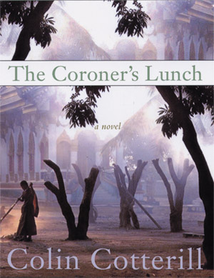
I like the characters, especially the funny ones. I also enjoy reading about how they live and what they eat. It is very different food, weather and lifestyle than in the United States.

Colin Cotterill

Mr. Cotterill has written many books and also is a cartoonist. I emailed him to let him know how much I enjoyed reading the Dr. Siri books and he emailed me back!

He used to be a PE teacher in England but has lived in Thailand for a very long time. First he worked for an agency that helped children now he works full-time as an author and a cartoonist.

You can check out his website here!

